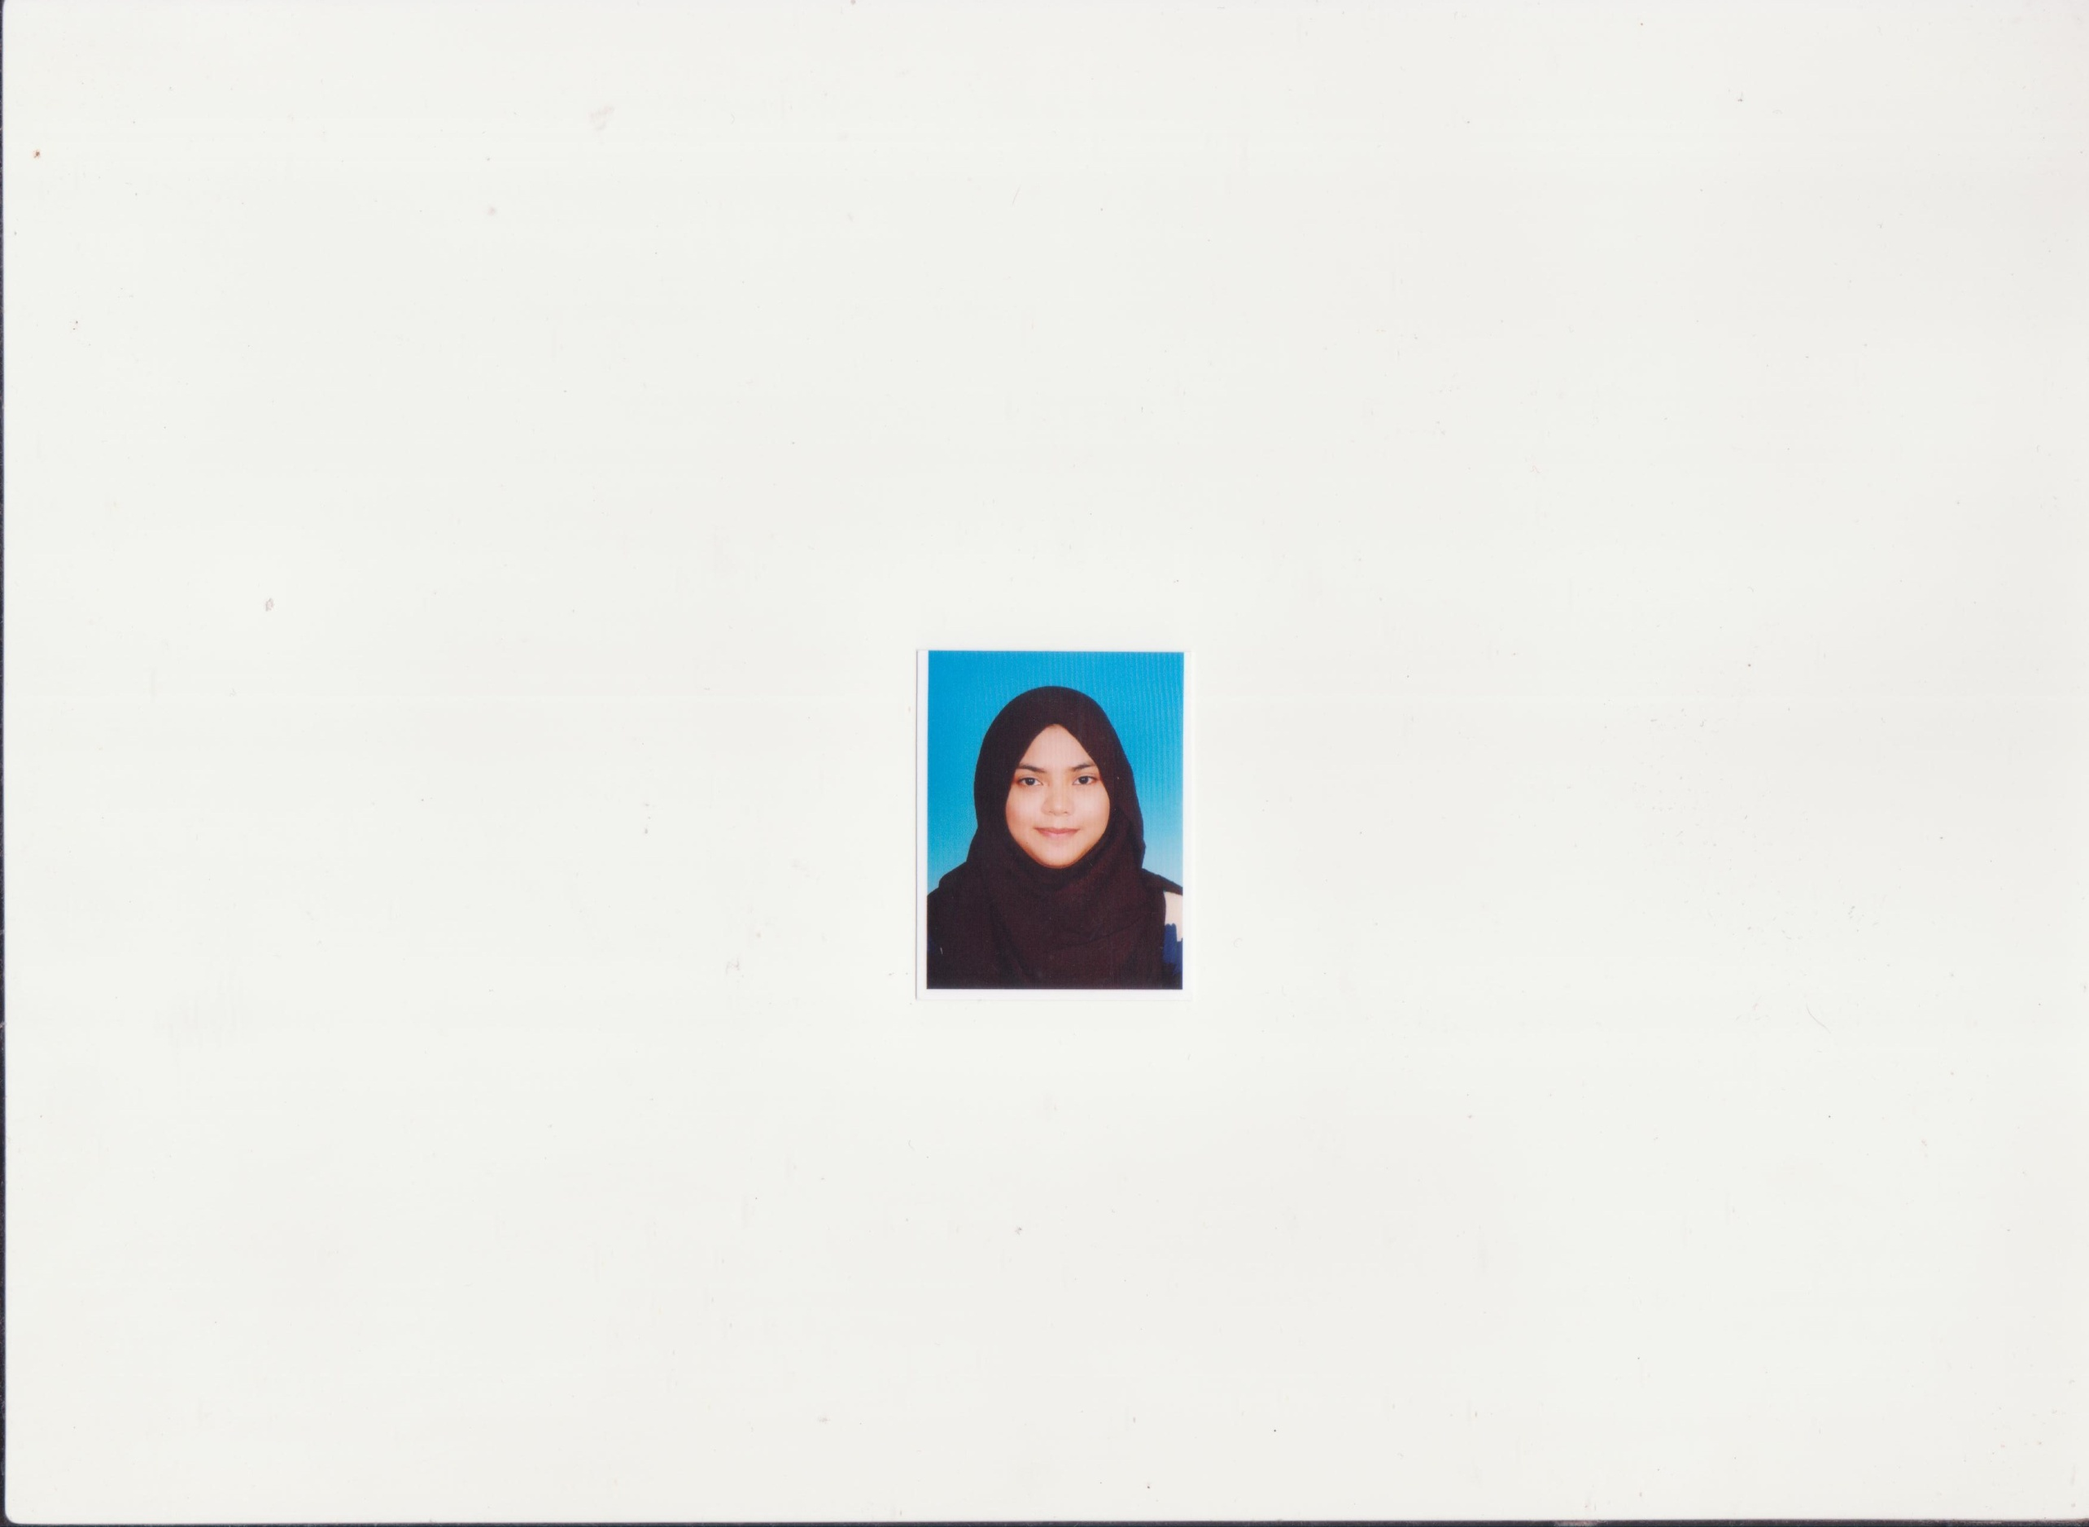

SAFWAH BINTI MOHD SABRI

**PERSONAL PARTICULAR**

IC NO : 940622-08-5492

EMAIL ADDRESS : safwahsabri_94@yahoo.com.my

ADDRESS : PT 10188, KAMPUNG AIR KUNING, AIR KUNING, CHANGKAT JERING, 34850 TAIPING PERAK.

MOBILE NO : 011-27040168

AGE : 22 YEARS OLD

DATE OF BIRTH : 22 JUN 1994

RACE & RELIGION : MALAY AND ISLAM

NATIONALITY : MALAYSIA

**EDUCATION**

1. NAME OF INSTITUTION : POLITEKNIK SULTAN SALAHUDDIN ABDUL AZIZ

SHAH, SHAH ALAM

EDUCATION LEVEL : DIPLOMA IN BUSINESS STUDY

MAJOR : MANAGEMENT

CGPA (SEM 1-6) : 3.32

1. NAME OF INSTITUTION :SEKOLAH MENENGAH TEKNIK TAIPING, PERAK

EDUCATION LEVEL : SPM (2011)

RESULT : 6A, 1B, 1C

**WORK EXPERIENCE**

**SUN-TRIDENT SDN BHD**

(ACCOUNT ASSISTANT)

PERIOD: 18 AUGUST 2015 UNTIL NOW

TASK:

* Assist account executive in full set account.
* Filing and updating weekly Ledger Account General, Debtors & Creditors.
* Assist in monthly payroll, liaised with EPF, Socso & Cleared Income Tax.
* Prepared Trial Balance, Balance Sheet and Profit & Loss account & Bank reconciliation in Autocount Accounting System.
* Prepare and process invoices.
* Handling incoming calls for the department.
* Others clerical work

**PEJABAT MARA, TAIPING PERAK**

(INDUSTRIAL TRAINING)

PERIOD: 6 MONTH (1 DIS 2013 – 18 APRIL 2014)

TASK:

* ASSITED IN ALL COUNTER ACTIVITIES SUCH AS ACCEPTED CUSTOMERS PAYMENT
* RECEIVING AND ATTENDING TO CUSTOMERS ENQUIRIES AT THE COUNTER
* ASSITED IN MANAGE ALL OFFICE DOCUMENT

**TITECH COMPUTER, TAIPING PERAK.**

(TECHNICIANS)

PERIOD: 4 MONTH (PART TIME)

TASK:

* REPAIR CUSTOMER COMPUTER
* MANAGE CUSTOMERS PAYMENT SYSTEM ON THEIR PURCHASE
* CHECK ALL THE STORE STOCK

**EXTRA CO-CURICULUM ACTIVITIES**

POLITEKNIK SULTAN SALAHUDDIN ABDUL AZIZ SHAH, SHAH ALAM (2013-2015)

* MEMBER OF KELAB KELANA SISWA
* PARTICIPATED IN HARI WANITA
* MANAGED A SEMINAR PENGURUSAN SUMBER MANUSIA
* COMMITTEE IN CORPORATE SOCIAL RESPONSIBLE (CSR) AT BUKIT CERAKAH, SHAH ALAM
* COMMITTEE IN CORPORATE SOCIAL RESPONSIBLE (CSR) AT TAMAN TADISMA, SHAH ALAM

SEKOLAH MENENGAH TEKNIK TAIPING, PERAK (2010-2011)

* SECRETARY OF “PENGAWAS PUSAT SUMBER”
* TREASURER OF PANDU PUTERI
* TREASURER OF KELAB KEBUDAYAAN
* PARTICIPANTS CAMPING PANDU PUTERI AT SCHOOL

SEKOLAH MENENGAH KAMPUNG JAMBU, PERAK, 2007-2009,

* PARTICIPANTS MARCHING KADET PKBM (LAUT), SCHOOL LEVEL
* PARTICIPANTS WITH SHOOTING AT CAMP KADET PKBM (LAUT)

**RELATED SKILLS AND KNOWLEDGE**

* PROFICIENT IN MICROSOFT OFFICE WORD, POWER POINT, EXCEL, Sage UBS COMPUTERISED ACCOUNTING AND AUTOACCOUNT ACCOUNTING SYSTEM.
* SPEAK AND WRITE FLUENT BAHASA MALAYSIA AND FAIR IN ENGLISH.
* POSSESS A DRIVING LICENSE (B2).

**LANGUAGE**

|  |  |  |
| --- | --- | --- |
| **LANGUAGE** | **SPOKEN** | **WRITTEN** |
| BAHASA MALAYSIA | 10 | 10 |
| ENGLISH | 6 | 6 |
| **JOB PREFERENCE** |  |  |
| EXPECTED SALARY : RM1500 (Negotiate)  WILLING TO TRAVEL : YES  WILLING TO RELOCATE : YES  POSSESS OWN TRANSPORT : YES  **OTHER INFORMATION**   * I CAN ADAPT ANY WORKING ENVIROMENT * I AM A RESPONSIBLE AND HONEST PERSON * I AM WILLING TO LEARN AND ACCEPT ANY JOB THAT RELATED * I AM HARDWORKING AND HIGH MOTIVATED PERSON |  |  |

**REFERENCE**

**NORAIZURA BINTI ISHAK**

PEGAWAI MARA DAERAH LARUT/MATANG&SELAMA,

PEJABAT MARA TAIPING,

LOT 3B & 5B KEDAI BUSINESS CENTRE,

JALAN TUPAI, 34000 TAIPING PERAK.

(019-6757130)

**WONG WAI LENG**

SUN TRIDENT SDN BHD

NO 38-1 JALAN KUCHAI MAJU 6,

KUCHAI ENTERPRENEUR’S PARK,

OFF JALAN KUCHAI LAMA,

58200 KUALA LUMPUR

(03-79838380)